Exercise 6
Fibonacci sequence in VNMSim
Our team chose the Fibonacci sequence because each new term is made by adding the previous two. This gives us a small program where we can practise the accumulator, temporary registers, and an unconditional jump.
Algorithm
We start with T1 = 0 and T2 = 1. Each pass adds them and saves the sum in T3. We then move the old T2 into T1 and the new sum from T3 into T2. JMP 5 returns to LOD T1, so the next pass uses the latest pair.
Program used
// Fibonacci loop
LOD #0
STO T1
LOD #1
STO T2
LOD T1
ADD T2
STO T3
LOD T2
STO T1
LOD T3
STO T2
JMP 5
The code listing starts with a comment at row 0, so the loop begins at row 5. JMP 5 sends execution back to LOD T1. This version has no stop instruction, so we paused VNMSim manually after each checkpoint. T3 is overwritten on the next pass, so we recorded its value before it changed.
Results recorded in VNMSim
Checkpoint | T1 | T2 | T3 / new term | Status
Before loop | 0 | 1 | — | Starting values
After pass 1 | 1 | 1 | 1 | Seen in VNMSim
After pass 2 | 1 | 2 | 2 | Seen in VNMSim
After pass 3 | 2 | 3 | 3 | Seen in VNMSim
After pass 4 | 3 | 5 | 5 | Seen in VNMSim
After pass 5 | 5 | 8 | 8 | Prediction; not captured
The first four checkpoints match the VNMSim screenshots. The fifth pass should give T1 = 5, T2 = 8 and T3 = 8, but we did not capture it; it is a prediction, not a measured result.
Testing and limitations
We recorded four consecutive passes from one run; they are checkpoints, not tests with different input datasets. The program starts from fixed values 0 and 1, has no input variable, and continues until it is stopped manually. It keeps only the latest terms in T1, T2 and T3. A counter and conditional jump could make a finite run, but we did not add or test that version.
How we used AI
AI helped us discuss the Fibonacci update and understand JMP 5. It first suggested checking jump support and deciding how to observe the sequence. We described our rolling-register idea, and AI checked the register progression and pointed out that JMP loops indefinitely. AI later proposed a counter with JMZ; we kept our simpler JMP 5 program. We entered the code, checked the jump address, and compared the first four register states in VNMSim. The counter/JMZ version was not implemented or tested.
Team contributions and self-assessment
The contribution and speaking-role entries below are a draft based on the work described in this report. Each member should check that their row matches what they actually did.
Team member | Actual contribution (complete) | Speaking role (confirm with team)
Nikita | Proposed the Fibonacci idea and wrote an early code version. | Explain the task and Fibonacci rule; show how the program works.
Kevin | Worked through the instruction sequence and prepared an explanation of how the registers are updated. | Explain the code and the roles of T1, T2, and T3.
Illia | Ran the program in VNMSim, checked the register values, saved screenshots, and reviewed the AI suggestions. | Present the test screenshots and explain how the team used AI.
Presentation timing
Part | Time
Task and goal | 2 minutes
AI discussion | 3 minutes
Code and registers | 3 minutes
VNMSim demonstration | 2 minutes
Conclusion | 2 minutes
Questions | 3 minutes
Total | 15 minutes

Exercise 6 screenshots
Image 6.1. After pass 1: T1 = 1, T2 = 1, T3 = 1.
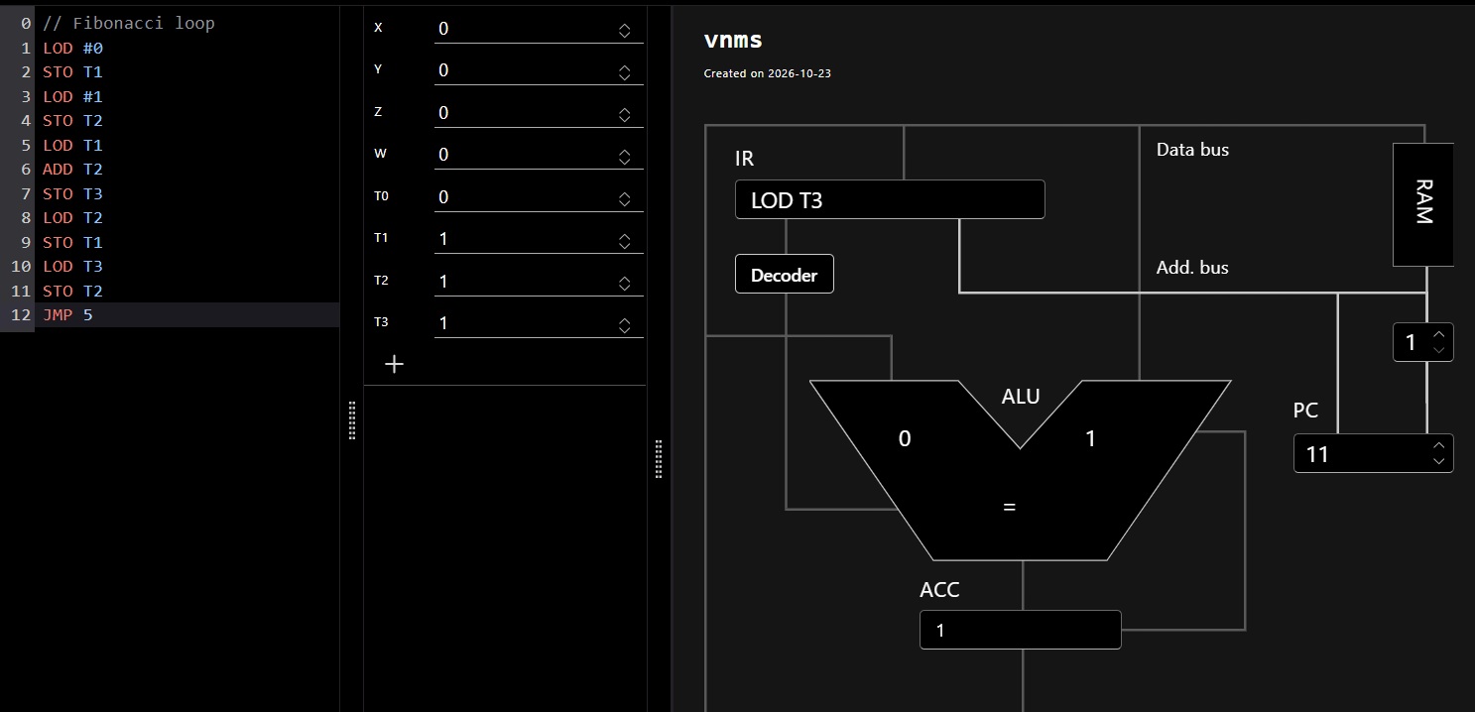
Image 6.2. After pass 2: T1 = 1, T2 = 2, T3 = 2.
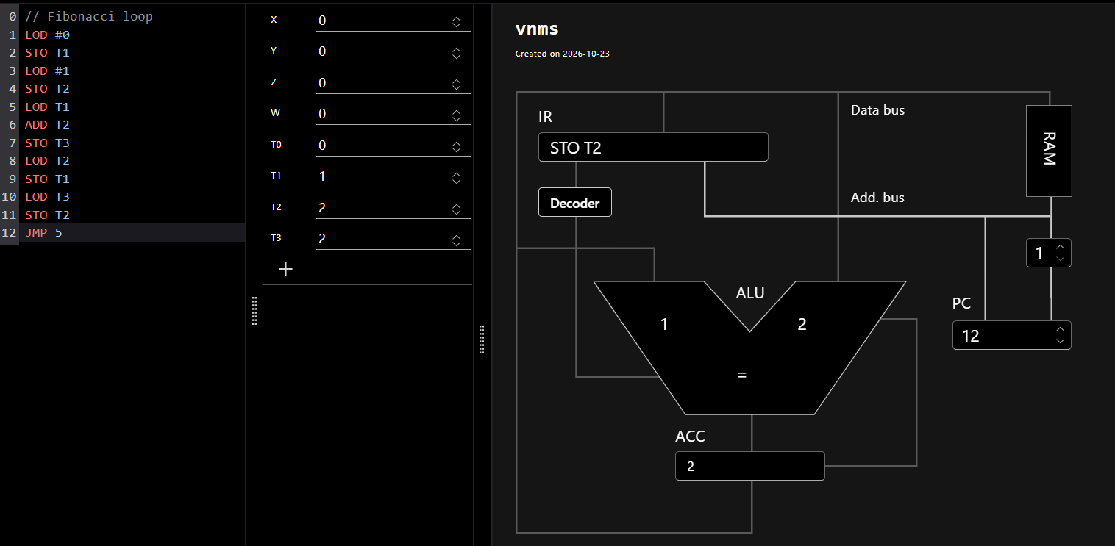
Image 6.3. After pass 3: T1 = 2, T2 = 3, T3 = 3.
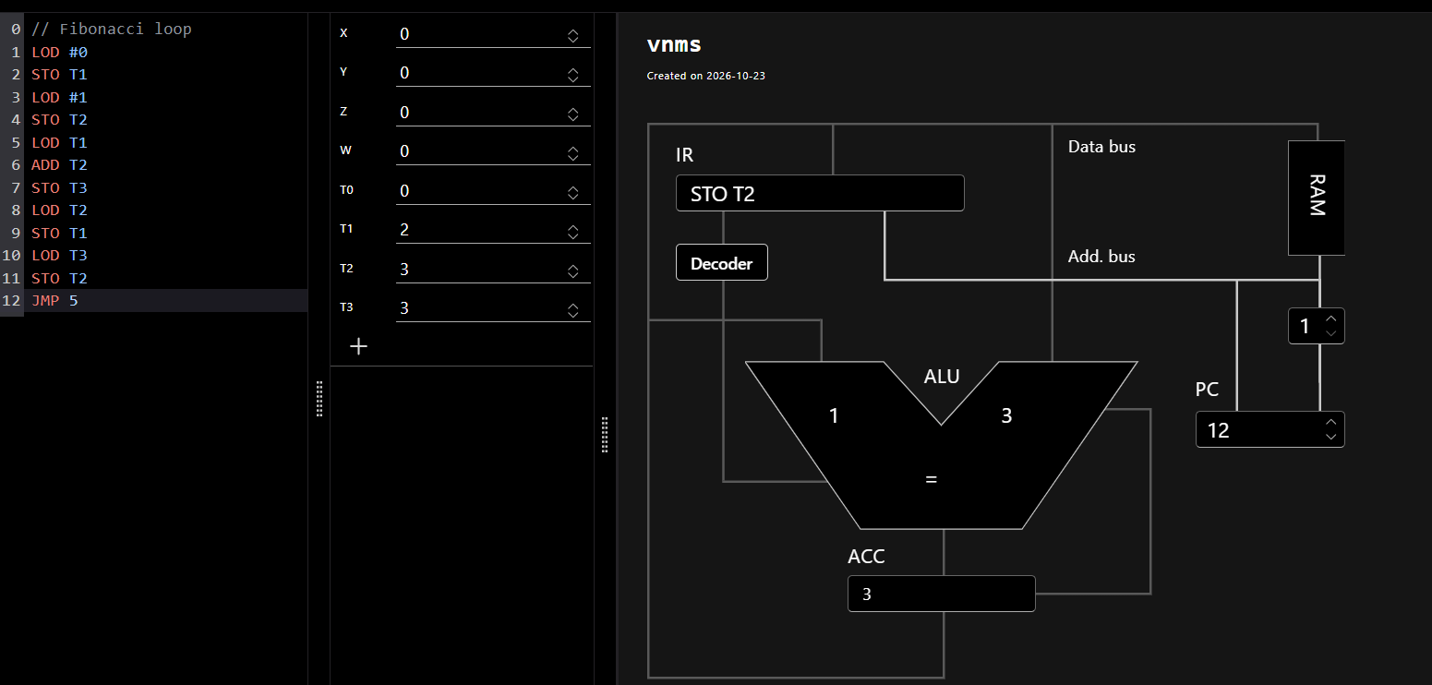
Image 6.4. After pass 4: T1 = 3, T2 = 5, T3 = 5.
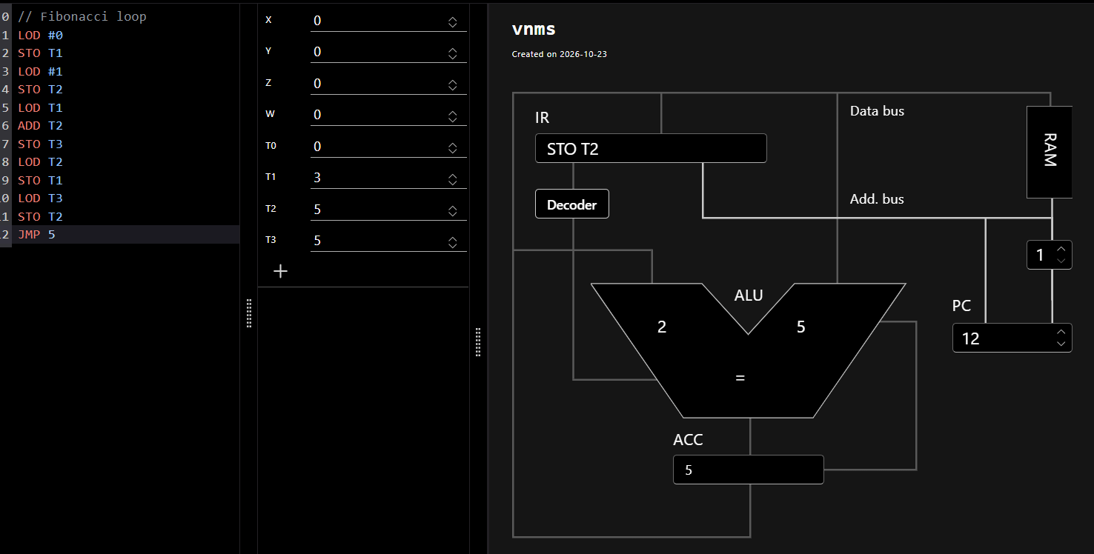

Individual self-evaluation
The ratings below are suggested drafts. Each member should confirm or change their own score and reason before submission.
Team member | Criterion | Score (1 to 5) | Personal reason and evidence
Nikita | Originality | 3 | We used a well-known sequence, but we had to turn its rule into a VNMSim loop.
Nikita | Complexity | 3 | The code is short. I spent most time understanding how the registers move and which address JMP uses.
Nikita | Solution quality | 5 | The first four saved states matched our expected values. The program still needs a stop condition.
Nikita | LLM co-development skills | 4 | AI helped me understand the loop and JMP 5. I checked the target and values in VNMSim; the counter suggestion is untested.
Kevin | Originality | 3 | The sequence itself is familiar, but translating it into VNMSim instructions was part of our work.
Kevin | Complexity | 4 | For me, the tricky part was following the order of LOD and STO so the program used the right terms.
Kevin | Solution quality | 4 | The screenshots show the expected register changes. The program works as a loop, although it does not stop automatically.
Kevin | LLM co-development skills | 3 | AI explanations helped me follow the code. I still needed to compare them with the listing and simulator results.
Illia | Originality | 3 | Fibonacci is a standard problem; our work was implementing it with three registers and a jump in VNMSim.
Illia | Complexity | 3 | The program is not long, but checking each pass took care because T3 changes every time around the loop.
Illia | Solution quality | 4 | I recorded four passes and checked them against the expected values. We did not capture pass five, and we stop the loop manually.
Illia | LLM co-development skills | 4 | AI gave us useful explanations, but I checked the jump and first four values in VNMSim. The counter/JMZ idea is still only a suggestion.
Team reflection on AI use
AI effectiveness rating (1 to 5) and reason: 4. AI helped us understand the rolling-register idea and JMP 5. We still checked the address and register values in VNMSim.
Helpful advice and how we checked it in VNMSim: AI explained that JMP 5 returns to LOD T1. We checked the address in the listing and compared the register states with the Fibonacci rule.
Limited or unused advice: AI suggested a counter with JMZ to stop after a fixed number of passes. We did not implement or test it, so we cannot say whether it would work in our program.
What we would change next time: We would decide earlier how to stop the program and plan the test screenshots before running it.
Working with AI compared with working alone: AI made it easier to discuss the idea and understand some instructions. We still had to check the explanations in VNMSim.
Appendix A: Selected excerpts from our AI discussion
These shortened excerpts come from our saved chat transcript. They show how we used AI to discuss the idea, check the register pattern, and understand the loop instruction. We entered and checked the simple loop in VNMSim ourselves. The counter/JMZ version discussed below was not implemented or tested.
Stage | Chat excerpt and what our team did
Planning | Our prompt: "we working on exercise 6 and we have idea is to generate Fibonacci numbers in VNMSim using a loop." AI suggested checking jump support, deciding whether to show one term or a sequence, and considering the simulator number range. We chose a rolling-register Fibonacci program.
Checking the algorithm | We explained how T1 and T2 are added into T3, then shifted for the next pass. AI confirmed the rolling-window pattern and noted that T3 is overwritten and JMP keeps the loop running. We used the register values as checkpoints.
Understanding JMP | We asked for one instruction to return to address 5 without changing the program into a counter version. AI replied: "Add JMP 5 at address 12. It unconditionally sends execution back to address 5." We entered the instruction and checked the first four passes in VNMSim.
Evaluating another idea | We also asked about a counter with JMZ. AI proposed a bounded-loop version. We kept our simpler JMP 5 program and paused it manually; the counter/JMZ proposal was not tested, so we do not report it as a verified result.

